**Logical Thinking**

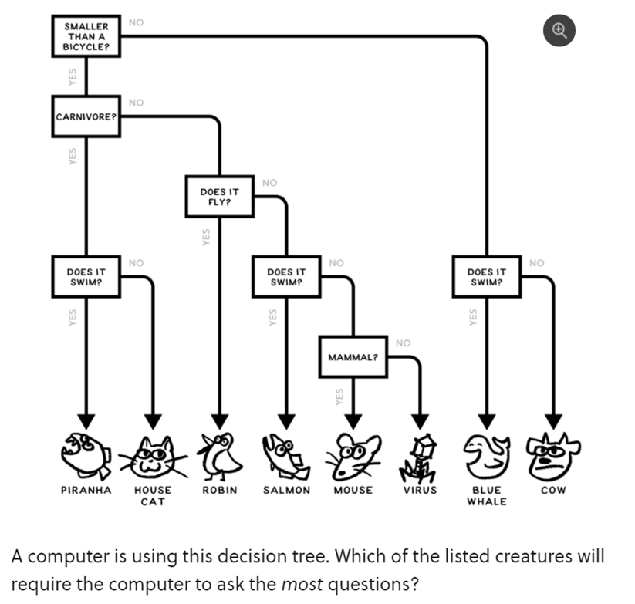

Choice of answer (a) Hose cat (b) mouse (c) cow (d) Salmon

Based on the above question

**Ans: B mouse**

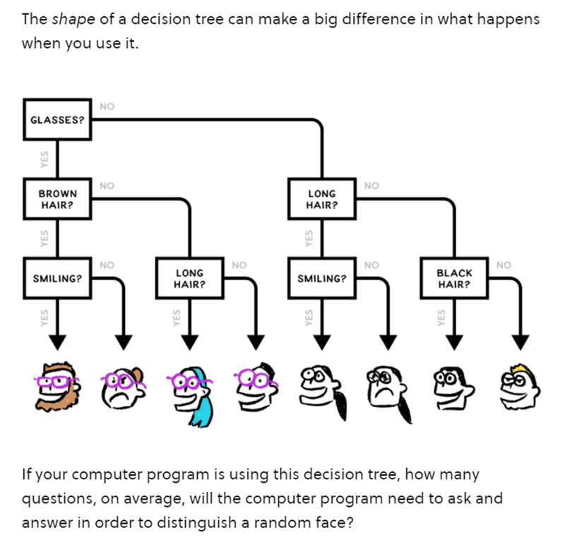

Choice of answer (a) 2 **(**b) 3 (c) 4 (d)7

Ans b **3**

1. **the goal is to arrange the number tiles from the bank to boxes so all of the boxes' conditions are satisfied. All the tiles below have the same number. For example, below 1 is 1 and below 0 are 0s**

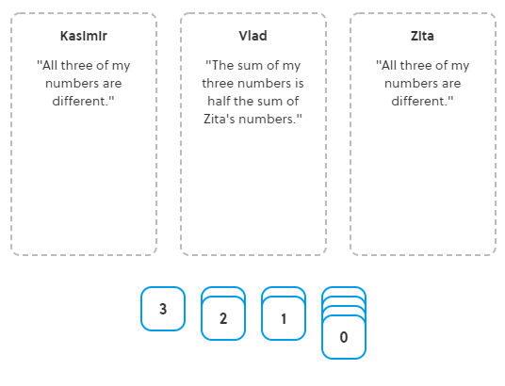 **What is the sum of Kasimir's numbers?**

**Question description is not understandable.**

1. 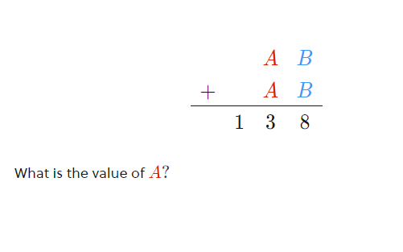

Ans Value of A is 6

1. You are given one array of integers. Write a function which returns the highest prime number from the given array of integers. The array of integer is the input parameter of the function.

//function to check whether number is prime or not

static bool isPrime(int n)

{

if (n <= 1)

return false;

// Check from 2 to sqrt(n)

for (int i = 2; i < Math.Sqrt(n); i++)

if (n % i == 0)

return false;

return true;

}

This function returns maximum prime number

static int maxPrime(int[] arr){

int max=0;

for(int i=0; i<arr.Length;i++){

if(isPrime(arr[i]) && arr[i]>max){

max=arr[i];

}

}

return max;

}

**Algorithmic thinking**

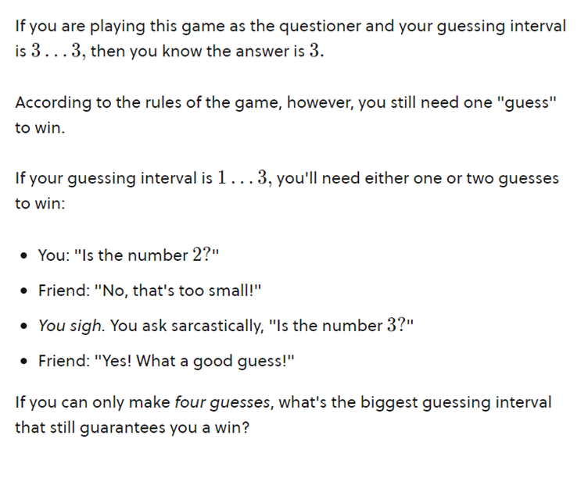

1. 1…..7 (b) 1….31   (c ) 1….15

c)